Technical Architecture:

Project Design Phase-II Technology Stack (Architecture & Stack)

Date | 26 June 2026
Team ID
Project Name | Ucab – Cab Booking System
Maximum Marks | 4 Marks

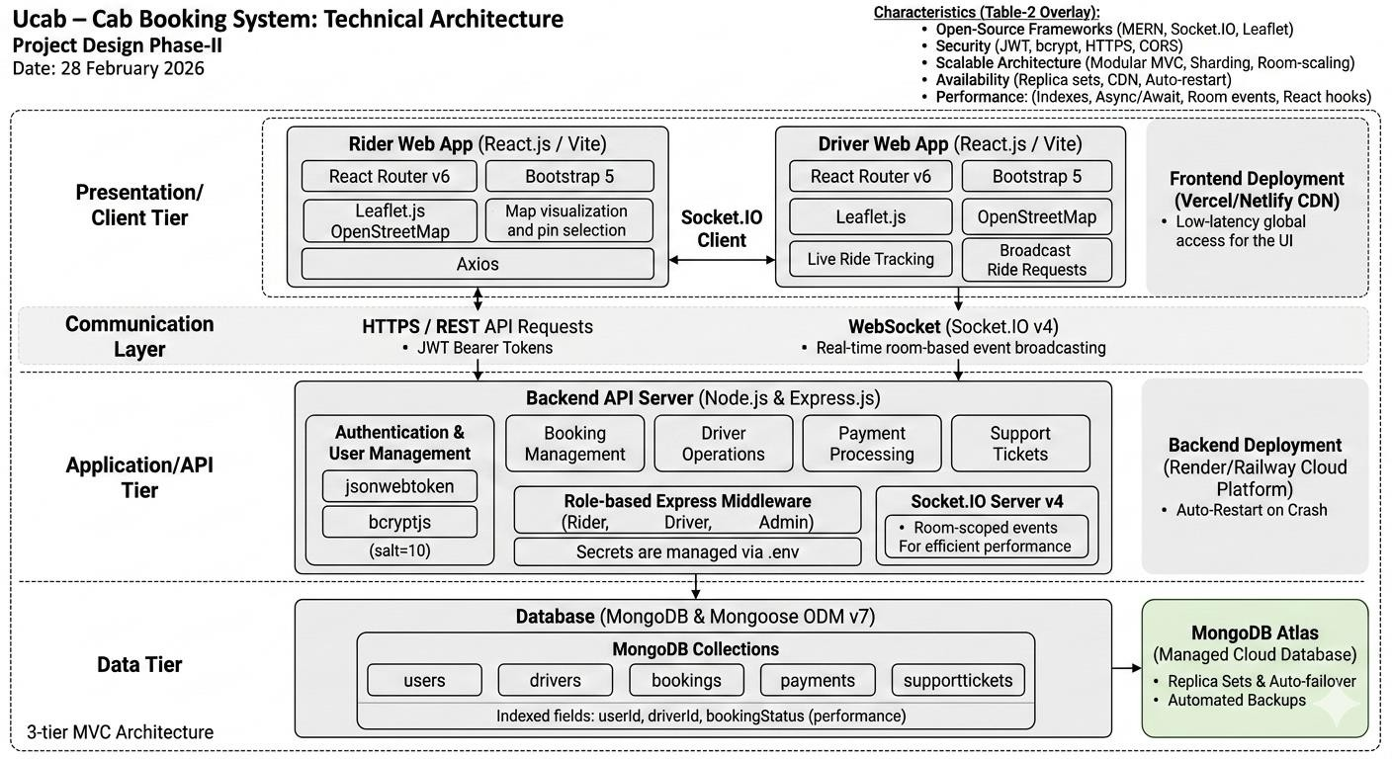

Table-1 : Components & Technologies:
The Deliverable shall include the architectural diagram as below and the information as per the table1 & table 2

S.No | Component | Description | Technology
1. | User Interface | Web UI for Riders (booking, tracking, payment, history) and Drivers (dashboard, ride management).  Fully responsive. | React.js (Vite), React Router v6, Bootstrap 5, Leaflet.js, Axios, Socket.IO  Client
2. | Backend API Server | RESTful API handling auth, bookings, driver operations, payments, and support tickets. JWT-  protected role-based routes. | Node.js v18+, Express.js, bcryptjs, jsonwebtoken, Mongoose ODM
3. | Real-Time Communication | Broadcasts ride requests to driver rooms; notifies  rider on acceptance; cancels pending requests for other drivers. | Socket.IO v4 (WebSocket) — room-based event broadcasting
4. | Database | NoSQL document store. Collections: users, drivers,  bookings, payments, supporttickets. Indexed on userId, driverId, status. | MongoDB (NoSQL) with Mongoose ODM v7
5. | Cloud Database | Managed cloud MongoDB with automated backups, replica sets, and auto-failover for high availability. | MongoDB Atlas — connected via MONGO_URI environment variable
6. | Map & Location Service | Interactive map for pickup/drop-off pin selection, nearby cab display, and live ride path rendering in  browser. | Leaflet.js + OpenStreetMap (open-source, no API key required)
7. | Infrastructure / Deployment | Dev: Node.js (port 5000) + Vite dev server (port  5173). Production: cloud-hosted backend and CDN frontend. | Render/Railway (backend), Vercel/Netlify (frontend), .env for secrets

Table-2: Application Characteristics:

S.No | Characteristics | Description | Technology
1. | Open-Source Frameworks | All libraries are open-source: MERN stack, Socket.IO, Leaflet, Bootstrap, Axios, bcryptjs, jsonwebtoken. | React (MIT), Node.js (MIT), Express (MIT), MongoDB/Mongoose (Apache 2.0), Socket.IO (MIT), Leaflet (BSD-2),  Bootstrap (MIT)

2. | Security | Passwords hashed with bcrypt (salt=10). All API routes protected by JWT Bearer tokens. Role-based  Express middleware enforces Rider/Driver/Admin separation. Secrets in .env only. | bcryptjs, jsonwebtoken, role-based Express middleware, CORS, HTTPS (production)
3. | Scalable Architecture | 3-tier MVC: React frontend / Express REST API / MongoDB. Modular route-controller pattern — each module (auth, bookings, drivers, payments, support)  independently deployable. | Modular Express routes, MongoDB Atlas sharding, Socket.IO room-based scaling
4. | Availability | MongoDB Atlas replica sets provide automatic failover. Frontend on CDN ensures low-latency global access. Backend platform auto-restarts on  crash with zero manual intervention. | MongoDB Atlas replica sets, Vercel/Netlify CDN, Render/Railway auto-restart
5. | Performance | MongoDB queries indexed on userId, driverId, bookingStatus for fast lookups. Axios async/await prevents UI blocking. Socket.IO broadcasts only to relevant rooms. React useState minimises re-  renders. | MongoDB indexes, Axios async/await, Socket.IO room-scoped events, React useState

